**Exercise 1: Configuring a Basic Spring Application**

**Scenario:**

Your company is developing a web application for managing a library. You need to use the Spring Framework to handle the backend operations.

**Steps:**

**1. Set Up a Spring Project:**

**o Create a Maven project named LibraryManagement.**

**Ans.**

Step 1: - Go to File > New > Other...

Step 2: -Select Maven > Maven Project and click Next.

Step 3: -Select Create a simple project (skip archetype selection) and click Next.

Step 4: -Enter the Group Id as com.library and Artifact Id as LibraryManagement.

Step 5: -Click Finish.

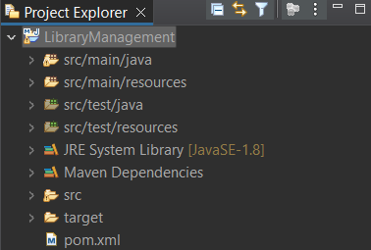

**o Add Spring Core dependencies in the pom.xml file.**

Open the pom.xml file in the root of the project LibraryManagement. Then type :-

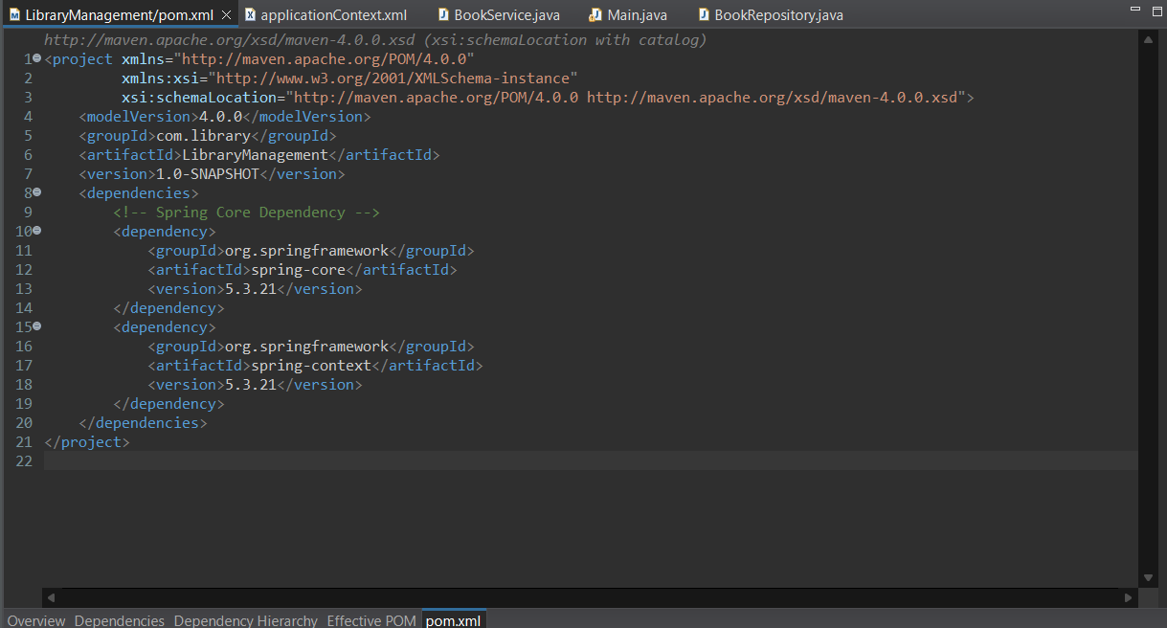

**2. Configure the Application Context:**

**o Create an XML configuration file named applicationContext.xml in the src/main/resources directory.**

**Ans.**

Step 1: -Right-click on src/main/resources.

Step 2: - Select New > Other... > General > File and click Next.

Step 3: -Enter the file name as applicationContext.xml and then click of Finish.

**o Define beans for BookService and BookRepository in the XML file.**

**Ans.**

Open the applicationContext.xml file and type the following configuration.

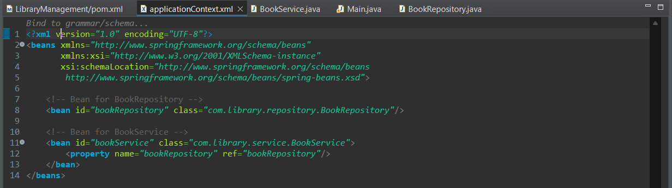

**3. Define Service and Repository Classes:**

**o Create a package com.library.service and add a class BookService.**

**Ans.**

Step 1: -Right-click on src/main/java and select New > Package.

Step 2: - Enter com.library.service as the package name and click Finish.

Step 3: - Right-click on the newly created package and select New > Class.

Step 4: - Enter BookService as the class name and click Finish.

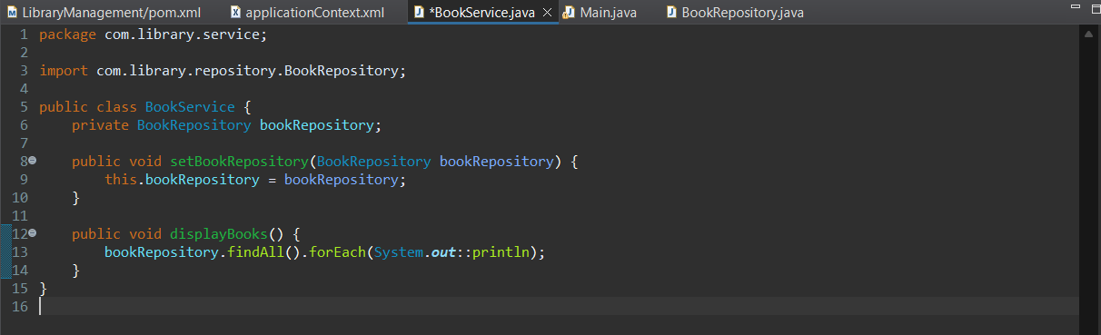

**o Create a package com.library.repository and add a class BookRepository.**

**Ans.**

Step 1: -Right-click on src/main/java and select New > Package.

Step 2: -Enter com.library.repository as the package name and click Finish.

Step 3: -Right-click on the newly created package and select New > Class.

Step 4: -Enter BookRepository as the class name and click Finish.

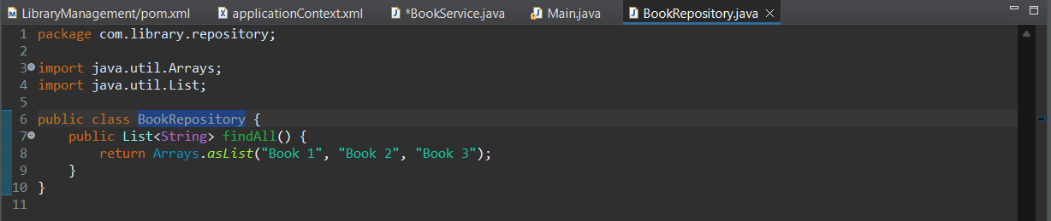

**4. Run the Application:**

**o Create a main class to load the Spring context and test the configuration.**

**Ans.**

Step 1: -Create a package named com.library.main

Step 2: -Create a main class to load the Spring context and test the configuration.

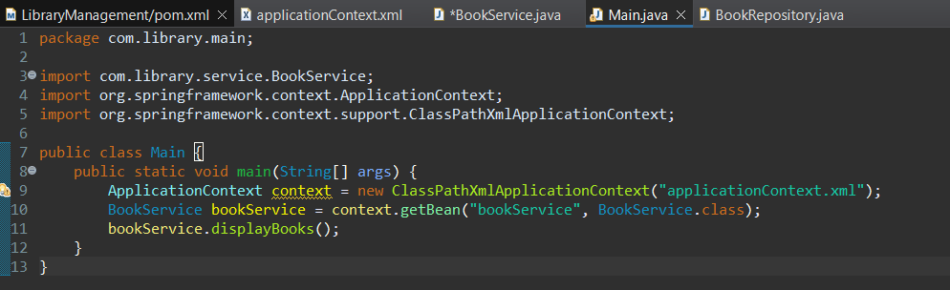

**OUTPUT:-**

